Title of the Publication Goes Here
⚫ The title of the manuscripts should be concise, informative, and in capital letters (Only first letter needs to be upper case).

ABSTRACT
Manuscripts should be written in English. Abstracts not more than 200 words for a full paper and 100 words for a short paper outlining the scope and contributions of the paper, are required.

Keywords: Keywords (no more than 4 words) should be given and placed below the abstract.

1. Heading
⚫ Section headings should be concise and numbered sequentially, using a decimal system for subsections.

1. Heading (bold)
1.1. Heading (bold italics)
1.1.1. Heading (italics)
⚫ The Manuscripts should be typed single -column , double-spaced , using a font size of 11 points or larger within 30 pages. The length of a manuscript submitted should not exceed 30 single-column, double-spaced pages including figures and illustrations for a full paper.

1.1. Use of Units
⚫ The submitted manuscripts must use SI (Metric) Units in text, figures, or tables. English units may be included parenthetically

1.1.1. Citation
- Sources are cited in the text, usually in parentheses, by the author's surname, the publication year of the work cited. Full details are given in the reference list (under the heading References).
One author: (Smith 2012) or Smith (2012)
Two authors: (Smith and Jones 2012) or Smith and Jones (2012)
Three authors: (Smith, Jones, and Khan 2012) or Smith, Jones, and Khan (2012)
Four or more authors: Smith et al. (2012) or (Smith et al. 2012)
- If the reference list contains two publications in the same year that would both shorten to the same form (e.g. Smith et al. 2012), list a and b to distinguish the two references.
- References cited in tables or figure legends should be included in the reference list.

1.2. Table Style
Table 1. This is table caption .
- Any words in the table must upper case for the first letter.
- The table has only three lines.
- Tables should present new information rather than duplicating what is in the text. Readers should be able to interpret the table without reference to the text. Please supply editable files.
Title1 | Title2 | Title3
Text | Write text here | Text
Text | Write text here | Text
Text | Write text here | Text
Text | Write text here | Text
Text | Write text here | Text

1.3. Formula Style
- Use plain-italicize setting for symbols and use bold-italicize setting for vectors and matrices.
- All equations need to be numbered and add punctuation marks.
- Equation's E capital in the text.
- List “Nomenclature”above reference list.
x + y = z . (1)
2. Reference Section

Samples for listing your references
Book | One author | Smith, J. J. 2012. Book Title. London: Routledge.
Book | One author | Smith, J. J. 2012. Keynes, Beveridge and Beyond. London: Routledge.
Book | Two authors | Smith, J. J., and J. B. Jones. 2012. Book Title: The Subtitle. London:  Routledge.
Book | Two authors | Smith, J. J., and J. B. Jones. 2012. Keynes, Beveridge and Beyond.  London: Routledge.
Book | Three authors | Smith, J. J., J. B. Jones, and M. Green. 2012. Book Title: The Subtitle.  London: Routledge.
Book | Three authors | Smith, J. J., J. B. Jones, and M. Green. 2012. Keynes, Beveridge and Beyond. London: Routledge.
Book | Four to ten  authors | Give all authors’ names.
Book | More than  ten authors | List the first seven authors followed by et al.
Book | Chapter in a single-author book | Green, M. 2012. “Chapter Title.” In Style Manual, 33-44. London:  Routledge.
Book | Chapter in a multi-author book | Jones, S. 2012. “Chapter Title.” In Book Title, edited by J. Smith, 341– 346. London: Routledge.
Book | Organization  as author | University of Chicago Press. 2012. The Chicago Manual of Style. 16th  ed. Chicago: University of Chicago Press.

 | Edited | Smith, J., ed. 2012. Collected Style Manuals. London: Routledge.
 | Edited | Smith, J., and J. Jones, eds. 2012. Collected Style Manuals. London:  Routledge.
 | Edition | University of Chicago Press. 2012. The Chicago Manual of Style. 16th  ed. Chicago: University of Chicago Press.
 | Multivolume  work | Green, M. L. 2012. Collected Correspondence. Vol. 2 of The Collected Correspondence of M. L. Green. London: Routledge, 2000-.
 | Multivolume  work | Khan, L. 2009–12. Collected Works. 2 vols. London: Routledge.
 | Translated | Smith, J. 2012. Collected Style Manuals. Translated and edited by J.  Jones. London: Routledge.
 | Not in English | Piaget, J., and B. Inhelder. 1951. La genèse de l’idée de hasard chez l’enfant [The Origin of the Idea of Chance in the Child]. Paris: Presses  Universitaires de France.
 | Online | Smith, J. 2012. Book Title: The Subtitle. London: Routledge. doi:  xxxxxxxxxxx.
 | Online | Smith, J. 2012. Book Title: The Subtitle. London: Routledge.  http://xxxxxxxxx/.
Journal | One author | Smith, J. J. 2012. “Article Title: The Subtitle.” Journal Title in Full 10 (1): 30–40. doi: xxxxxxxxxxx.
Journal | One author | Evans, W. A. 1994. “Approaches to Intelligent Information Retrieval.” Information Processing and Management 7 (2): 147–168. doi:  12345678900.
Journal | Two authors | Smith, J., and M. Green. 2012. “Article Title: The Subtitle.” Journal Title in Full 10 (1): 33–39. doi: xxxxxxxxxxx.
Journal | Two authors | Smith, J. J., and L. M. Khan. 2012. “Approaches to Intelligent Information Retrieval.” Information Processing and Management 7  (2): 147–168. doi: 12345678900.
Journal | Three authors | Smith, J. J., J. P. Jones, and M. G. Green. 2012. “Approaches to  Intelligent Information Retrieval.” Information Processing and

 |  | Management 7 (2): 147–168. doi: 12345678900.
 | Four to ten authors | Give all authors’ names.
 | More than  ten authors | List the first seven authors followed by et al.
 | Unpublished work Book or  journal article | Use Forthcoming instead of the date.  Smith, J. in press. “Article Title: The Subtitle.” Journal Title in Full. doi: xxxxxxxxxxx.
 | Unpublished work Book or  journal article | If an article is not yet accepted, treat as a thesis.  Smith, J. 2008. “Title of Thesis.” Name of Institution.
 | Translated | Lisa, K. 2012. “Article Title in English.” [In Hindi.] Journal Title in Full 10 (3): 10–29. doi: xxxxxxxxxxx.
 | Other article  types | Smith, J. 2012. “Title of Book Review.” Review of Book Title, by L.  Khan. Journal Title in Full 10 (1): 33–39. doi: xxxxxxxxxxx.
Conference | Proceedings  -Book style -Journal style | Individual contributions to conference proceedings are treated like chapters in multi-author books. If published in a journal, treat as an  article.
Conference | Proceedings  -Book style -Journal style | Eberhart, R. C., and Y. Shi. 1998. “Comparison Between Genetic Algorithms and Particle Swarm Optimization.” In IEEE Proceedings of Congress on Evolutionary Computation, Anchorage, AK, 4-9 May  1998: 611-616. Washington, DC: IEEE.
Conference | Proceedings  -Book style -Journal style | Jiang, D., W. Du, and X. Chen. 1997. “GA Based Location Models for Physical Distribution Certers.” In Proceedings of IEEE International Conference on Intelligent Processing System, edited by J. Smith,  Anchorage, AK, 4-9 May 1998: vol: 6: 611-616. Washington, DC: IEEE.
Conference | Proceedings  -Book style -Journal style | Lighthill, M. J., and J. B. Whitham. 1955. “On Kinematic Waves. I. Flow Movement in Long Rivers. II. A Theory of Traffic Flow on Long Crowded Reads.” Proceedings of Royal Society 229 (1178): 281-345.
Conference | Paper | Smith, J. 2012. “Title of Paper.” Paper presented at the annual meeting for the Society of XXX, Oxford, 21–24 November 2012.

 | Poster | Smith, J. 2012. “Title of Poster.” Poster presented at the annual  meeting for the Society of XXX, Oxford, 21–24 November 2012.
Thesis |  | Smith, J. 2008. “Title of Thesis.” PhD dissertation, University of Chicago.
Internet | Document | Oxford Library. 2012. “Library Strategy.” Oxford Library. Accessed June 3. http://www.ol.org/library/strategy.html.
Patent |  | Green, A. Year. Patent description. US Patent 12345.
Patent |  | Cho, S. T. 2005. Optical Perforating Apparatus and System. US Patent 6,980,855.
Patent |  | Cho, S. T. 1981. Optical Perforating Apparatus and System. European Patent Application 0021165 A1. 1981-01-07.
Other reference types | Audio and  visual media | Bernstein, Leonard, dir. Symphony no. 5, by Dmitri Shostakovich.  New York Philharmonic. CBS IM 35854.
Other reference types | Audio and  visual media | Auden, W.H. Poems. Read by the author. Spoken Arts 7137. Compact  disc.
Other reference types | Audio and  visual media | Cleese, J., T. Gilliam, E. Idle, T. Jones, and M. Palin. “Commentaries.” Disc 2. Monty Python and the Holy Grail, special ed. DVD. Directed by T. Gilliam, and T. Jones. Culver City, CA: Columbia Tristar Home  Entertainment, 2001.
Other reference types | Database | Name of Database (details; accessed Month Day, Year).  http://xxxxxxxxxxxxxxxxxxxxxxx/.
Other reference types | Standard | BSI (British Standard Institution). 2003. Bituminous Mixtures Test Methods for Hot Mix Asphalt, Wheel Tracking. European Standard.  EN 12697-22. London: British Standard Institution.
Other reference types | Standard | 3GPP (3rd Generation Partnership Project). 2010. Evolved Universal terrestrial Radio Access (E-UTRA); Further Advancements for E-UTRA Physical Layer Aspects (Release 9). 3GPP TR 36.814 v9.0.0. Valbonnl,  France: 3rd Generation Partnership Project.
Other reference types | Standard | IEEE (The Institute of Electrical and Tronic Engineering). 2010.  Amendment to IEEE Standard for Local and Metropolitan Area
Network–Part 16: Air Interface for Fixed and Mobile Broadband
Wireless Access Systems–Advanced Air Interface. IEEE 802.16.1-
00/01r4. New York: IEEE Standards Association.
 | Report | Bahia, H.U., and D.A. Anderson. 1995. The New Proposed Rheological Properties of Asphalt Binders: Why Are They Required and How do They Compare to Conventional Properties. Report No. STP 1241.  Washington, DC: American Society for Testing Materials.

3. Figures
- Please provide the highest quality figure format possible. Please be sure that all imported scanned material is scanned at the appropriate resolution: 1200 dpi for line art, 600 dpi for grayscale and 300 dpi for colour.
- All figures must be numbered in the order in which they appear in the manuscript (e.g. Figure 1, Figure 2). In multi-part figures, each part should be labelled (e.g. Figure 1(a), Figure 1(b)).
- The filename for a graphic should be descriptive of the graphic, e.g. Figure1, Figure2(a).
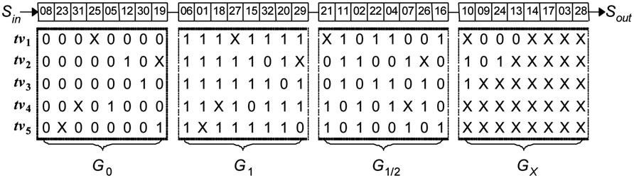
Figure 1. Test set after scan cell grouping.
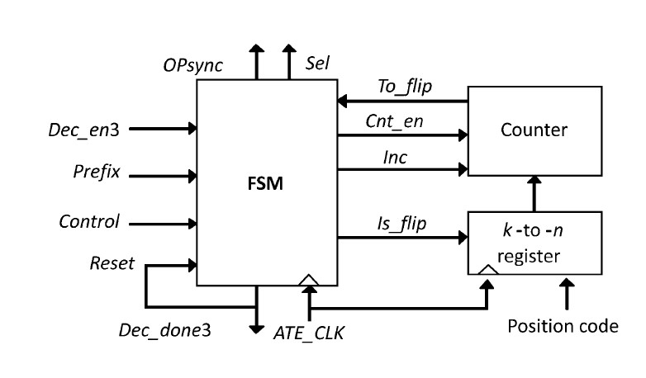
Figure 2. Test set after scan cell grouping.
Figure 3. Test set after scan cell grouping.

4. Copyright Notice
- Each manuscript must be accompanied by a Page Charge Form and a Copyright Agreementthat it has been neither published nor currently submitted for publication elsewhere (https://jcie.ntust.edu.tw/). Your manuscript will not be processed until both of the Page Charge Form and Copyright Agreement are received
- The JCIE will apply sanction against authors who are discovered to have made duplicate submission, which prohibits the authors/co-authors of any submissions, including new submissions and submissions in reviewing process.

